Samriddhi College

(Affiliated to Tribhuvan University)

Lokanthali-16, Bhaktapur

Project Report

On

**“Computer Parts”**

By : -

Aayush Dhakal (16134)

Rupesh Bhasima (16165)

Wilson Shrestha (16180)

|  |  |
| --- | --- |
| Document Status: | Ongoing |
| Version: | 1.0 |
| Issue Date: | September 15, 2021 |
| Department: | Bachelor in Computer Science and Information Technology  E-Commerce |

**ACKNOWLEDGEMENT**

The presented report entitled “Computer Parts” is prepared as an assignment of the subject “E-commerce”, B.Sc. CSIT 6th semester. This report is prepared on the basis of our own theoretical knowledge, guidelines, dedication, devotion and hard work.

We would like to express our deepest appreciation to all those who provided us the possibility to complete this report. We give our special gratitude to our 6th semester “Software Engineering” Professor, Mr. Sudip Raj Khadka, whose contribution in stimulating suggestions and encouragement helped us to complete this project.

**TABLE OF CONTENTS**

**LIST OF TABLES**

**1.**  **INTRODUCTION** 1

**1.1** **GENERAL INFORMATION** 1

**1.2** **BACKGROUND** 1

**1.3** **PROBLEM STATEMENT** 1

**1.4** **OBJECTIVE** 2

**2.** **BUSINESS MODEL** 2

**2.1 BUSINESS PROCESS** 2

**2.2** **MARKET ANALYSIS AND COMPETITIVE ANALYSIS** 3

**3. BUSINESS PROBLEM ANALYSIS AND SOLUTION** 3

**3.1 PROBLEM ANALYSIS**: 3

**3.2 SOLUTION:** 4

**4. SOLUTION MODEL** 4

**4.1 WEBSITE DESIGN:** 4

**5. CONCLUSION:** 7

**BIBLIOGRAPHY:** 7

**LIST OF FIGURES**

**4.1.1 Home Page4**

**4.1.2 Payment Gateway5**

**4.1.3 Admin Page6**

**EXECUTIVE SUMMARY**

To create an E-Commerce website for selling computer parts online was our mission. Oscar, which is an E-Commerce Framework for Django, was used to create our website. This project fits well in the market where the need for computer parts is ever growing. The online aspect of the project helps the buyers to compare and rate the available products more easily. The buyers can know the specification of the products in more detail without any assistance.

# **INTRODUCTION**

## **GENERAL INFORMATION**

E-commerce has seen massive growth in the recent internet era. It provides a convenient way of buying and selling of goods and services. The available products range in large numbers and it also allows users to select the most convenient product at the cheapest price possible.

Our project Computer Parts is an interactive e-commerce solution providing users with an opportunity to buy the computer hardware parts at an affordable price. Users can select the products from multiple renowned brands at the lowest cost possible. For the storage devices we provide a wide variety in their capacity which enables users to select the appropriate amount that fulfills their needs. So overall users can select the best fit by comparing all the available options.

## **BACKGROUND**

E-commerce is fast gaining ground as an accepted and used business paradigm. More and more business houses are implementing web sites providing functionality for performing commercial transactions over the web. It is reasonable to say that the process of shopping on the web is becoming commonplace. In the context of Nepal we have seen few emerging E-commerce solution providers like Daraz, SastoDeal who are doing considerably well in digitalizing the commerce.

## **PROBLEM STATEMENT**

This project provides a solution to the traditional expensive and time consuming commerce through an interactive e-commerce website. It also provides effective security measures that are required for safe and secure online transactions. The transactions are also comparatively cheaper than the traditional way of buying products in a physical store. So this project aims to provide a quick and cheap way of buying products online in a secure manner.

## **OBJECTIVE**

The project is about to provide a digital platform for the commerce of computer parts. Also it manages resources which were managed and handled by manpower previously. The main purpose of the project is to integrate distinct sections of the shop into a consistent manner so that complex functions can be handled smoothly. The project aims at the following matters

* Buying products
* To manage information of different types of items.
* Consistently update information on all the items.
* Managing security by providing authorized email & password.
* Managing databases efficiently.

# **BUSINESS MODEL**

## **2.1 BUSINESS PROCESS**

Our project “Computer Parts” is based on the Business to Consumer(B2C) E-Commerce Model since our website is focused on selling computer parts directly to consumers. A customer can view the products, choose it and order the same on our website. The advantages and disadvantages of creating this E-commerce project are:

Advantages:

1. Ability to handle multiple purchases of computer parts easily.
2. There is lower cost in maintaining the store.
3. We can easily retarget customers with recommendations.
4. Displaying detailed product information is possible.

Disadvantages:

1. Customers need to register on our website to order and checkout.

2. There are higher security risks and customer personal data may be leaked.

3. Customers need to wait for the product to be delivered.

4. Internet and funding is required to maintain the customer and product databases.

## **MARKET ANALYSIS AND COMPETITIVE ANALYSIS**

In terms of our country, the market size of computer parts is pretty small. However, the competition is high enough. Our competitors are mainly the offline computer storefronts. These storefronts provide customers with a wide range of selection and discounts. They are more open to different types of customers. Therefore, they have a larger customer base. They have more connections with the distributors.

However, if we are able to strike a deal with the distributors, we will be able to place newer parts and accessories for sale. Customers crave for new products in a market like ours. If we are able to provide new products faster to the customers, then we can increase our profit by a large margin. Moreover since we do not have a physical store as we are completely digital based, we will be able to cut down the expenses and by keeping the margin slightly lower we will be able to outshine in the competition and generate a decent profit.

# **3. BUSINESS PROBLEM ANALYSIS AND SOLUTION**

# **3.1 PROBLEM ANALYSIS**:

1. There are still trust issues and customers are hesitant to buy stuff online.
2. The online payment system is not robust and can fail in a country like ours.
3. The normal offline storefront is a huge competition in the market.
4. Customers cannot try the product before buying.
5. There is an extra overhead of maintaining the services and servers 24/7.

## **3.2 SOLUTION:**

1. Customers should be given an option to return the product after buying in a fixed amount of time.
2. Cash on Delivery option should be provided to the customers.
3. Better deals and discount schemes should be provided to the customers.

# **4. SOLUTION MODEL**

## **4.1 WEBSITE DESIGN:**

The project is made with the help of Django Oscar E-commerce framework with Sql as database. Oscar is an e-commerce framework for building domain-driven applications. It has flexibility baked into its core so that complicated requirements can be elegantly captured.

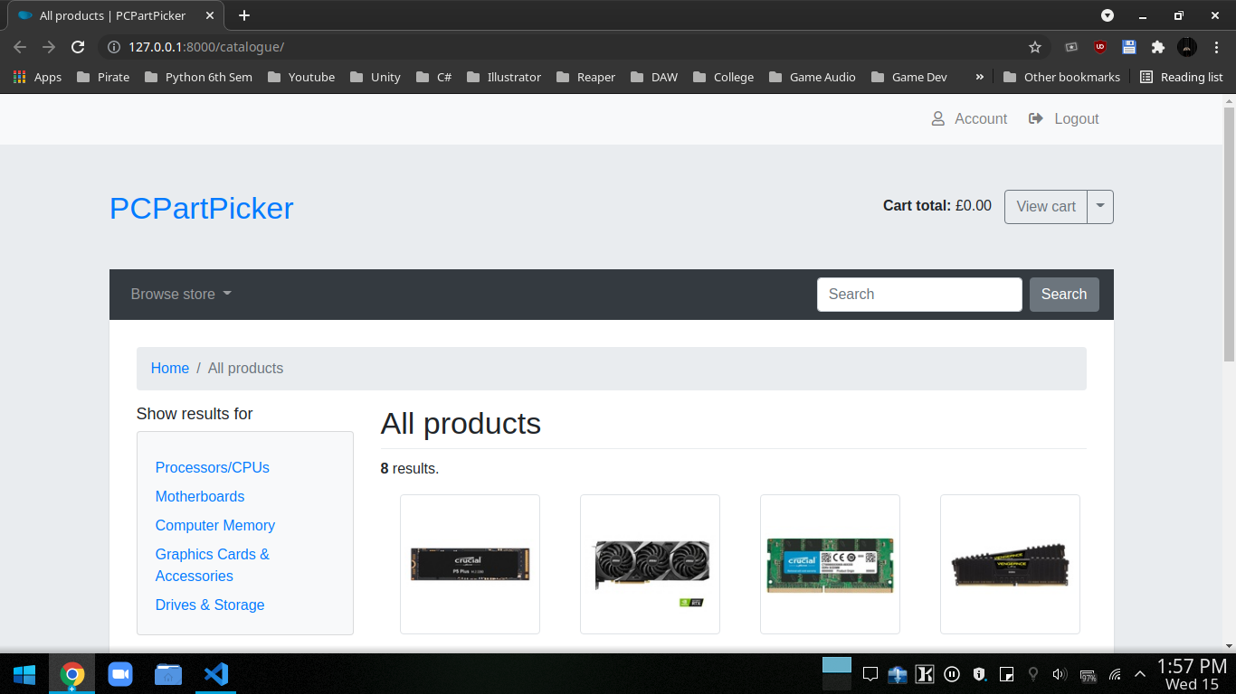

**Figure 4.1.1: - Homepage**

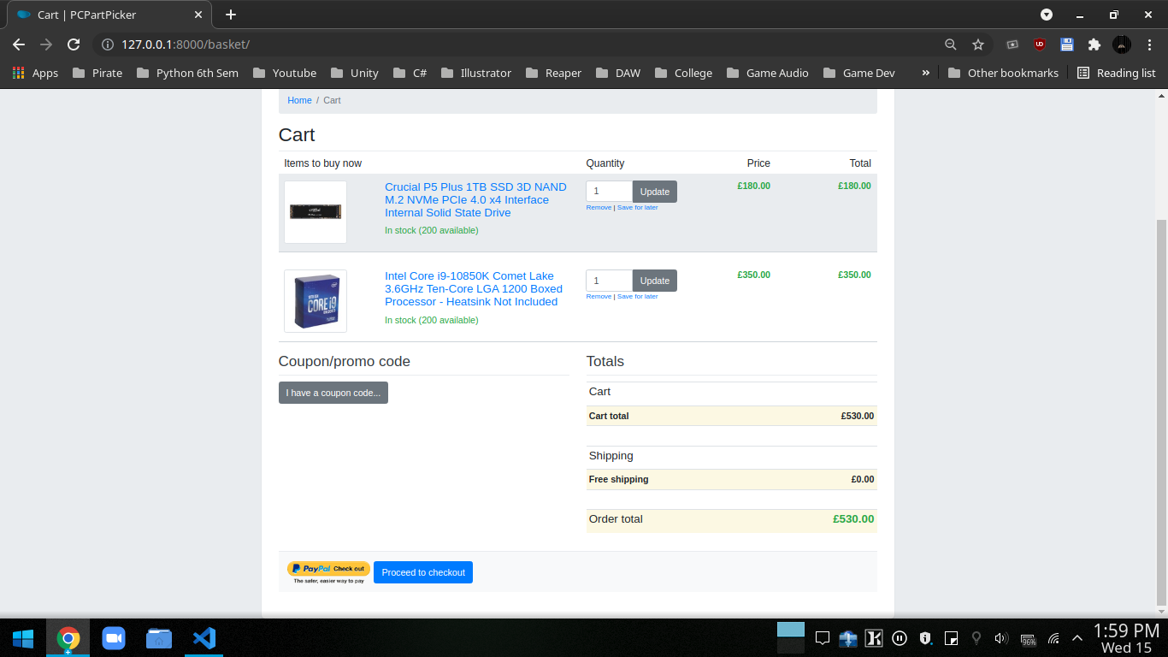

**Figure 4.1.2 Payment Gateway**

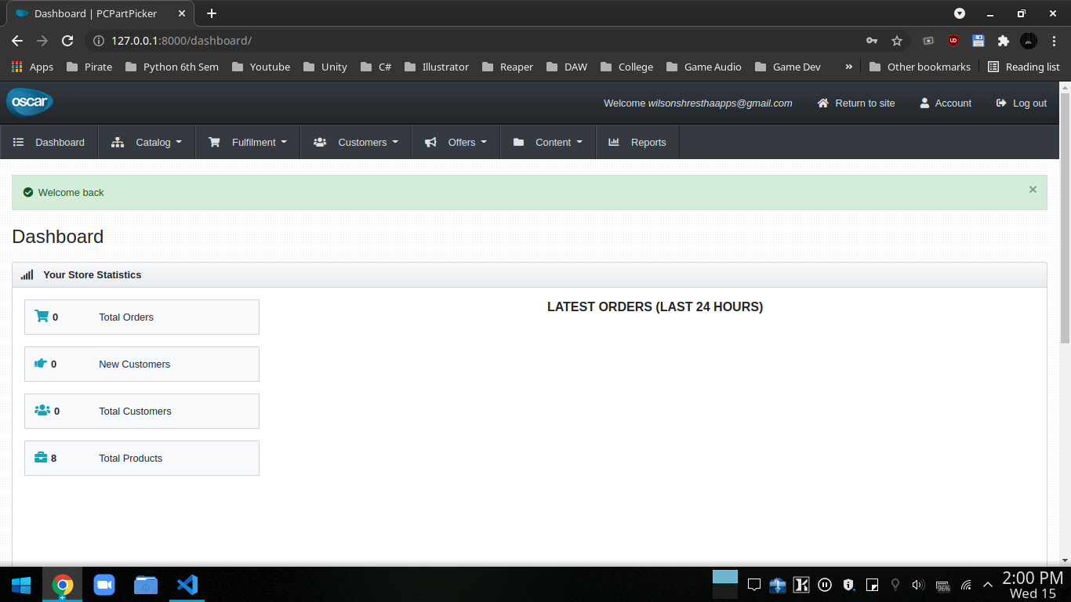

**Figure 4.1.3 Admin Page**

## **5. CONCLUSION:**

This website provides a digital version of computer parts shopping. It makes the entire process online where users can search for the product, buy the product and pay for the product as well. It also has a facility for users to login into the system where users can add the products to the cart and make the purchase. Moreover, it provides the facility of admin’s login where admins can add various items, review user’s activity and also give occasional discounts and also add info about different events for the customer.

## **BIBLIOGRAPHY:**

Computer Hardware Reseller Business Plan. (2019, August 9). Business Plans. https://www.bplans.com/computer-hardware-reseller-business-plan/market-analysis-summary/

Computer Support Business Plan. (2017, August 12). Business Plans. https://www.bplans.com/computer-support-business-plan/market-analysis- summary

E-Commerce - Business Models. (2009, May 12). Tutorials Point.https://www.tutorialspoint.com/e_commerce/e_commerce_business_models.htm

Oscar. (2021, May 2). Django Oscar Read Docs. https://django-oscar.readthedocs.io/en/3.1/